Styled components – use extension to vsc called vscode-styled-components for supporting syntax and highliting errors.
If you want to style build in html elements from 3rd library like navlink from react router you can put it inside brackets
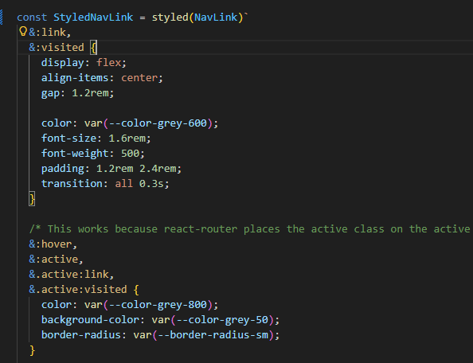



React-icons Is great icons library.

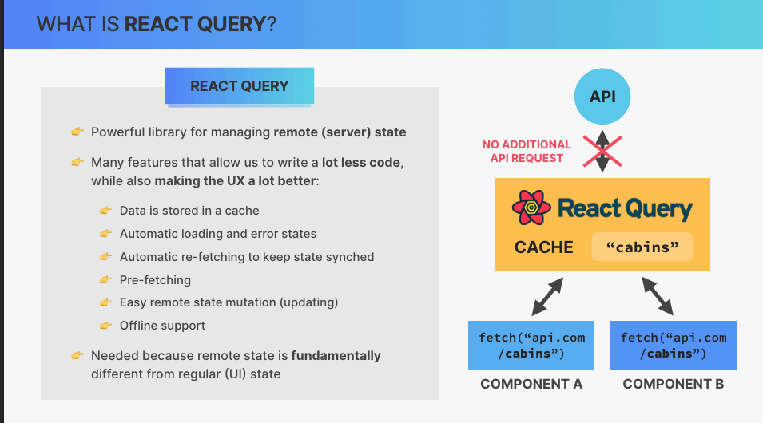

For better accessible for browser when we working with styled components use “role”
Then browser is sure its exatly table or row
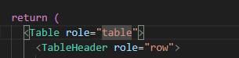
Verry pupular libarary to manipulation or calculation with dates 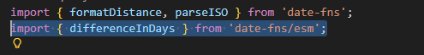
React-hot-toast – toast react library

The render props pattern – Allow us to render totally different component in certain component for example order list with different contentents. We need to include render prop as function that allow us to render this list> its not verry offen used but still can be usefull. Mostly we use custom hooks, but this example is perfect for render function.

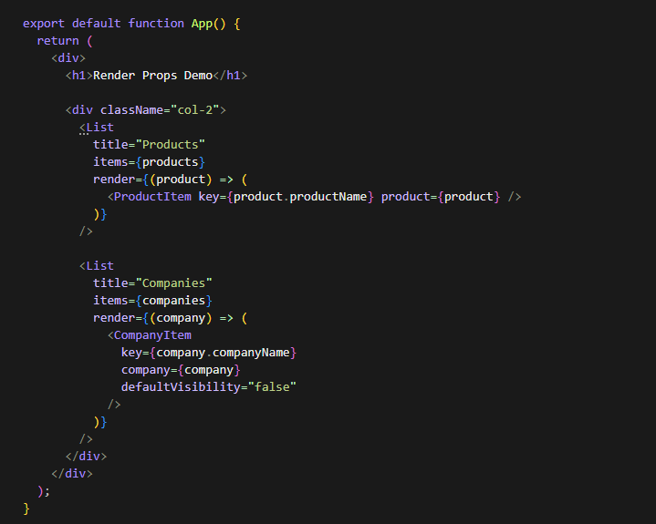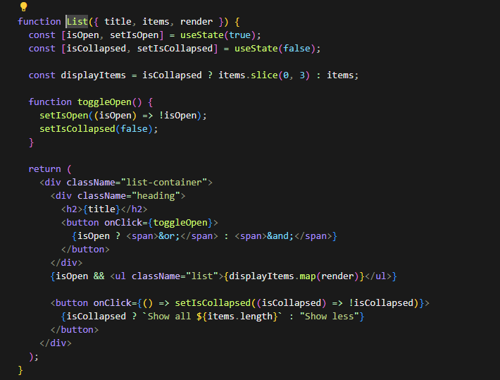
Higher-order component – Wrapper for component that allow to reuse logic. For example we can have reusable logic that add toggle for component (any component we want) and reuses it accrose app.
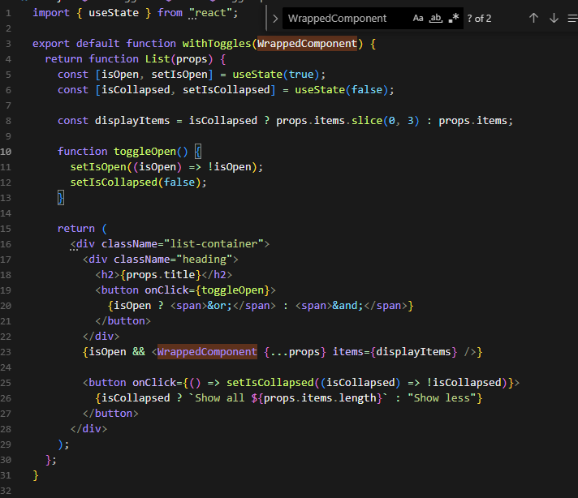

Compund component – Allow to create reusable components with flexible props. For example button that want to have label or antoher that will have lale and icon. Independent labet position (left/right). Help create flexible components without props hell

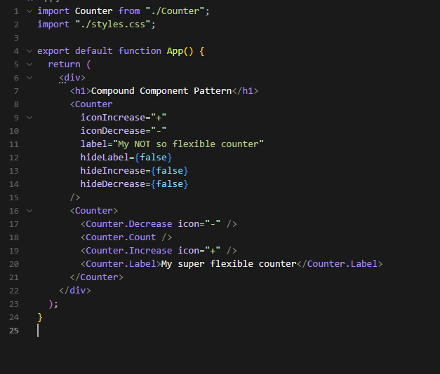


If you want to avoid cutting modal component (or different componenets) for example z-index or overflow you can use portal and assign your component to dom then I will render in top of the dom
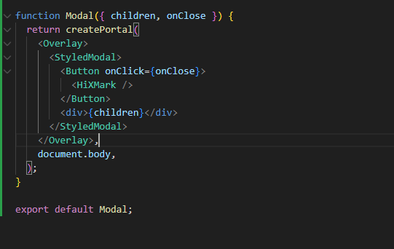
If you want to create reusable components you can use cloneelement nested function in react. It allows you to add behaviour to children for example you have attached button in <Modal.Open> </Modal.open> then you can create behaviour that clicking in button open your modal.
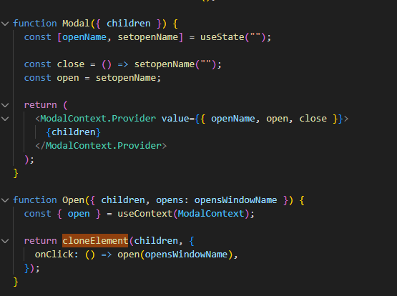

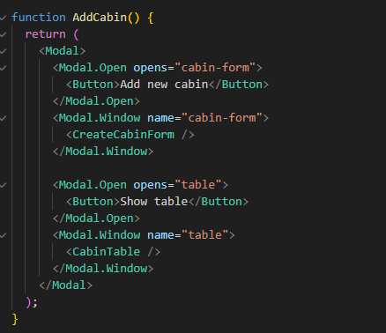
Neverthelless its not visible from modal perspective which can be confusing. Alternative for that is nesting child with function
